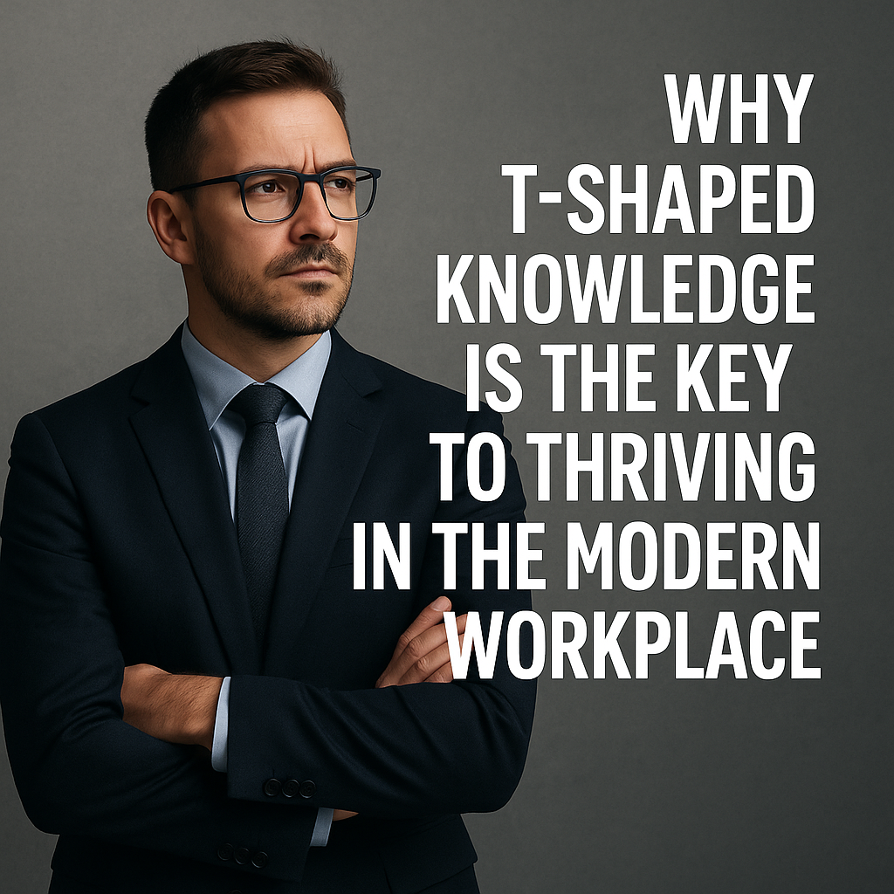In today’s fast-evolving professional landscape, success no longer belongs solely to specialists or generalists — but to those who master the balance between depth and breadth. This powerful combination is known as T-shaped knowledge or T-shaped skills, and it's becoming one of the most valued traits across industries like technology, design, business, and project management.

But what exactly are T-shaped skills? And why are they so important in today’s collaborative and multidisciplinary world?

✳️ ***Understanding T-Shaped Knowledge***

The concept of T-shaped knowledge was popularized by IDEO, a global design company known for innovation and cross-functional teamwork. They sought individuals who could go deep in one area while being able to connect and collaborate across others.

Let’s break it down:

📏 ***The Vertical Bar — Deep Expertise***

This vertical line of the “T” represents deep specialization in one field — your core area of strength.

**Examples:**

* *A software engineer who is an expert in Python programming*
* *A UX designer with mastery in user research and interface design*
* *A digital marketer highly skilled in SEO or content strategy*

This depth means you bring real value to a specific domain. You understand complex problems, best practices, and industry nuances. This is the space where you lead.

📐 ***The Horizontal Bar — Broad Knowledge***

The horizontal line of the “***T*** ” represents a broad understanding of related fields.

It’s not about mastering everything — it’s about knowing enough to collaborate effectively, ask the right questions, and contribute across boundaries.

***For example:***

* *That* ***Python*** *developer might understand front-end technologies, databases, and Agile workflows*
* *The* ***UX designer*** *may grasp branding, business strategy, and basic coding*
* *The* ***marketer*** *might be familiar with data analytics, customer experience, and sales funnels*

This breadth allows you to connect the dots between disciplines — a crucial skill in today’s interconnected work environments.

🚀 ***Why T-Shaped Skills Matter***

***1. Enhanced Collaboration***

T-shaped individuals can speak the language of other experts. They act as bridges between teams, making communication smoother and projects more cohesive.

***2. Holistic Problem-Solving***

With knowledge beyond their core, T-shaped professionals see the big picture. They pull insights from multiple areas to find creative, effective solutions.

***3. High Adaptability***

In fast-changing industries, narrow specialists often struggle to pivot. T-shaped people can learn quickly, adapt to new roles, and support different aspects of a project when needed.

***4. Greater Innovation***

Innovation thrives at the intersection of disciplines. T-shaped minds can connect ideas from unrelated fields to create fresh, breakthrough solutions.

***5. Accelerated Career Growth***

T-shaped professionals are more likely to rise into leadership roles, as they can understand and integrate perspectives from across the organization — not just their silo.

***6. Stronger Teams***

Teams composed of T-shaped individuals are more agile, balanced, and resilient. They can support each other’s gaps, cover more ground, and navigate complexity together.

🌱 ***How to Develop T-Shaped Skills***

If you want to grow into a T-shaped professional, here’s how to start:

* ***Go deep*** *in your area of strength — become the go-to person in at least one skill or discipline*
* ***Stay curious*** *— explore related areas through books, online courses, or cross-functional projects*
* ***Ask questions*** *when working with other departments or roles*
* ***Volunteer*** *for diverse tasks that stretch you beyond your comfort zone*

Join interdisciplinary teams to experience different workflows and mindsets

🧠 ***Final Thoughts***

In a world where teamwork, flexibility, and continuous learning define success, T-shaped knowledge is your greatest advantage.

Whether you're a student preparing for your future, a professional aiming for leadership, or a team builder assembling the ideal workforce — embracing the T-shaped mindset is essential.

*Go deep. Stay wide. And thrive in every direction.*

*“Specialists know more and more about less and less. Generalists know less and less about more and more. T-shaped professionals know what matters — and how to work together.”*

*Modern Workplace Philosophy*